Case Study Chapter 7

Mexicana Wire Winding, Inc.

Ron Garcia felt good about his first week as a management trainee at Mexicana Wire Winding, Inc. He had not yet developed any technical knowledge about the manufacturing process, but he had toured the entire facility, located in the suburbs of Mexico City, and had met many people in various areas of the operation.

Mexicana, a subsidiary of Westover Wire Works, a Texas firm, is a medium-sized producer of wire windings used in making electrical transformers. José Arroyo, the production control manager, described the windings to Garcia as being of standardized design. Garcia’s tour of the plant, laid out by process type (see Figure 7.20), followed the manufacturing sequence for the windings: drawing, extrusion, winding, inspection, and packaging. After inspection, good product is packaged and sent to finished product storage; defective product is stored separately until it can be reworked.

On March 8, Vivian Espania, Mexicana’s general manager, stopped by Garcia’s office and asked him to attend a staff meeting at 1:00 p.m.

“Let’s get started with the business at hand,” Vivian said, opening the meeting. “You all have met Ron Garcia, our new management trainee. Ron studied operations management in his MBA program in southern California, so I think he is competent to help us with a problem we have been discussing for a long time without resolution. I’m sure that each of you on my staff will give Ron your full cooperation.”

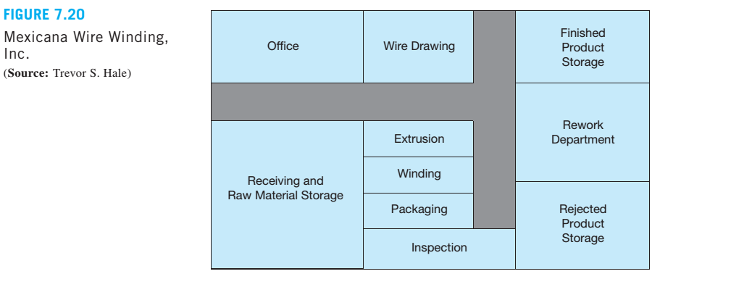

Vivian turned to José Arroyo, the production manager. “José, why don’t you describe the problem we are facing?”

“Well,” José said, “business is very good right now. We are booking more orders than we can fill. We will have some new equipment on line within the next several months, which will take care of our capacity problems, but that won’t help us in April. I have located some retired employees who used to work in the drawing department, and I am planning to bring them in as temporary employees in April to increase capacity there. Because we are planning to refinance some of our long-term debt, Vivian wants our profits to look as good as possible in April. I’m having a hard time figuring out which orders to run and which to back order so that I can make the bottom line look as good as possible. Can you help me with this?”

Garcia was surprised and apprehensive to receive such an important, high-profile assignment so early in his career. Recovering quickly, he said, “Give me your data and let me work with it for a day or two.”

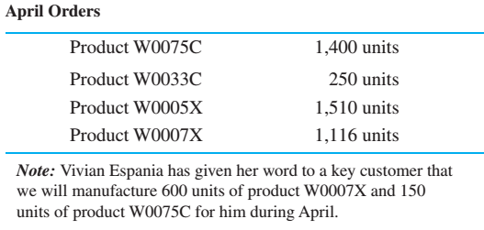

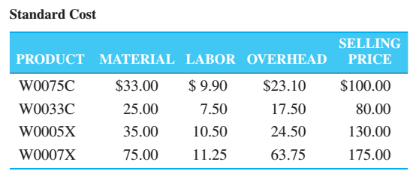

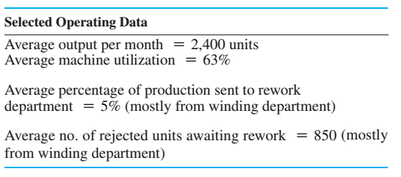

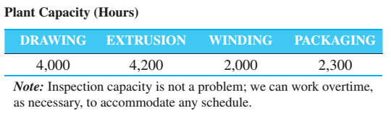

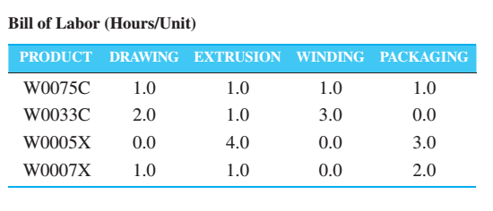

Discussion Questions

1. What recommendations should Ron Garcia make, with what justification? Provide a detailed analysis with charts, graphs, and computer printouts included.

2. Discuss the need for temporary workers in the drawing department.

3. Discuss the plant layout.

**Case Study Analysis Report**

As a business entity, the maximization of profit is the primary objective. The possible secondary objectives are commitments to customers, company reputation and quality of the products.

The Profit is revenue minus costs. The revenue is taken from the sales of every single unit of products. The costs in this case are the costs for material, labor and overhead. This way the profits for every single unit of each product is calculated.

The objective if to maximize the total profit by changing the cells of optimal units to be produced and by applying the constraints mentioned in the cells.

Objective: Z: f(X1,X2,X3,X4) = MAX {34 X1 + 30 X2 + 60 X3 + 25 X4 }

These constraints are the constraints about the orders to be placed for various units, the drawing capacity, extrusion capacity, winding capacity, packaging capacity, the orders for the key customer 75C and 07X.

**Excel Solver**

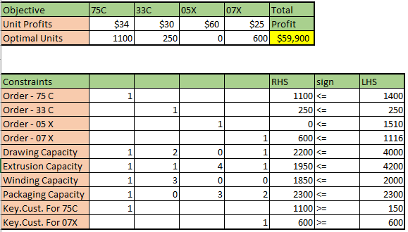

**Answer Report**

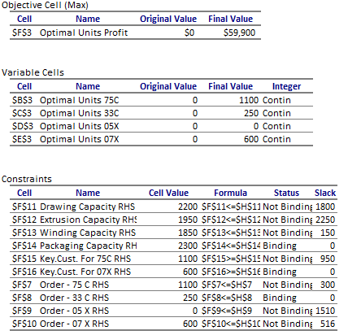

Mexicana wire is looking for maximizing their profits. Use Linear programming and getting the results by using the solver in Excel, the profit is $59,900 can be achieved from the manufacturing of 1100units of W0075C, 250 units of W0033C and 600 units of W0007X. The result also suggests not to produce W0005C product.

**Temporary workers in Drawing department:**

Assuming that by doubling the number of worker we can reduce the labor time in drawing department by 50%. But also increase the labor cost by 32% (4,000 hours out of total 12,500 hours). The following model is the modified model after reconsidering the labor time and labor cost.

Objective: Z: f(X1,X2,X3,X4) = MAX {30.83 X1 + 27.60 X2 + 56.64 X3 + 21.40 X4 }

**Excel Solver**

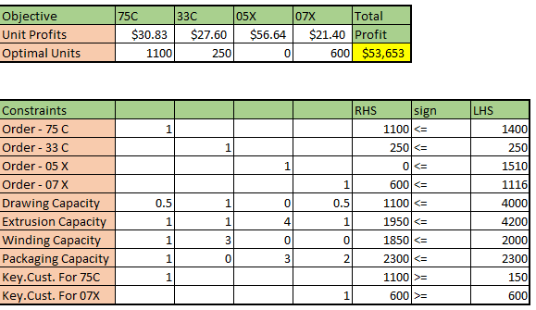

**Answer Report**

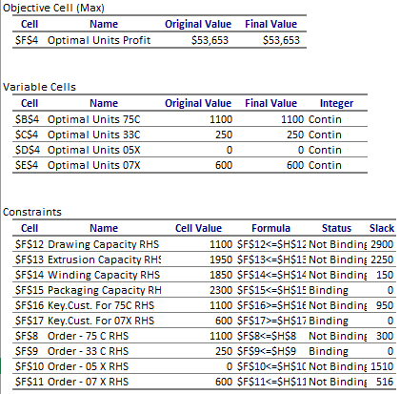

Looking at the additional temporary workers in the drawing department. Ron determined that by adding more headcounts in the drawing department, it is going to reduce the labor time, yet it increases the labor cost up to 32%. The quantity of product will still be same but will decrease the profit to $53,653 due to no increase in the pricing but burdened by the increases in production cost.

Ron’s recommendation should be produce 1100units of W0075C, 25 units of W0033C and 600 units of W0007X. Company must turn down the orders to produce 1510 units of W0005X, because it is better for the company not to increase the number of employee in the drawing department to keep the costs down.

**Plant Layout**

From the given diagram the modified plant layout would be with the receiving of materials and the different departments and then the rework department after the inspection if the goods need rework. And if the goods are all good then it can go into packaging and then finished goods storage.

And if the products are rejected after the rework then they are stored in the rejected product storage.

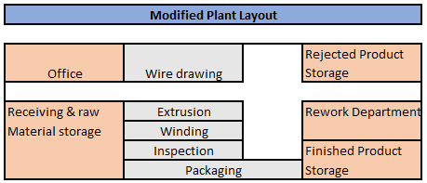

**The various departments of the Mexican wire plant are as follows:**

The finished good storage would happen only when after inspection the products are good and sent to packaging else they would be sent to the rework department as mentioned above.

